Experimental Psychology and Recent Computer Applications  
Introduction

Ankan Basu

New River Community College

For PSY200 Summer 2015

**Experimental Psychology and Recent Computer Applications  
Introduction**

Psychology is the study of behavior and mental processes including physical state, mental state and the environment. Psychological research involves description, explanation, prediction and control. Various methods of investigation are used in psychological studies. For a long time psychological research relied upon qualitative methods, thereby describing an object of interest, such as a particular behavior in response to certain events or some complex mental processes. The goal of experimental psychology is to precisely measure the outcome of an experiment, such that the findings can be duplicated and reproduced at a later stage. Wilhelm Wundt, known as the Father of Psychology, was the first person to develop an experimental psychology.

A simple model of psychological research involves formation of a research question, empirical study, data analysis, and conclusion. Statistics is very heavily used in the experimental psychology field. Furthermore, with the advancement of computer science, psychological research enjoys the power of computing and consequently utilizes many of the software packages developed to be used in psychology such as “Psych” – a program developed in R-programming language.

Experimental psychology helps the researcher test a hypotheses and solve real life problems. Experimental results also help one to make informed decisions. In a most basic experimental set up, dependent and independent variables are chosen wisely prior to a study to be conducted. Consequently scientists manipulate the independent variable while observing the effect on the dependent variable.

# Brief History of Experimental Psychology

This section presents a brief review of various psychology researchers who used various experimental methods to study mental processes and behavior. Such research typically involves human participants or animal subjects. In 1874, Wilhelm Wundt first published a textbook on experimental psychology named “Grundzüge der physiologischen Psychologie (Principles of Physiological Psychology)”. Later in 1899, he opened the first experimental psychology lab in Leipzig, Germany to conduct modern psychological research. The first modern psychological lab in the USA was started by well-known psychologist G. Stanley Hall in 1883. Next major contribution to the field of experimental psychology came from the published work by Herman Ebbinghaus where he documented his learnings from memory experiments in the book “Memory. A Contribution to Experimental Psychology”. With the growing interest in experimental psychology worldwide, the American Psychological Association was established in 1893 by G. Stanley Hall. Edwin Borin, who spent his entire career developing methods for psychological research published a landmark book “A History of Experimental Psychology” 1929. By this time, use of modern experimental methods in psychological studies were very common and the field continued to grow rapidly. Most recently, with the advent of computing power, various statistical programs are now highly used in psychological research. One of those computer programs that are now very highly regarded and used by top universities around the world is R[1] (or R-stat). This paper presents some of the advanced features and technologies developed to be used within the R programming interface to analyze, visualize and conduct experimental psychological research.

R in Statistical Research

The “R” or the “R Project for Statistical Computing” is a free open source programming language for statistical computing and graphical analysis. The R is supported by all major operating systems in the world including Windows, Linux and Mac OS[2]. The latest version of R is 3.2.1 and it was released as a stable version on 18th June, 2015.

Examples of R packages for Experimental Psychology:

* BaylorEdPsych:[3] A package developed for Baylor University Educational Psychology Quantitative Courses by A. Alexander Beaujean in February, 2015. This package uses 2011 Major League Baseball Offensive Data as an example dataset presented as “MLBOffense2011”. 2011 pitching data is also available with the package.

For example, The Cohen’s d (Cohen, 1988) value was calculated to be 0.6128 using the computer script below. Many other similar analyses can be performed using the package. Especially, missing data analysis function is very useful one in this particular package.

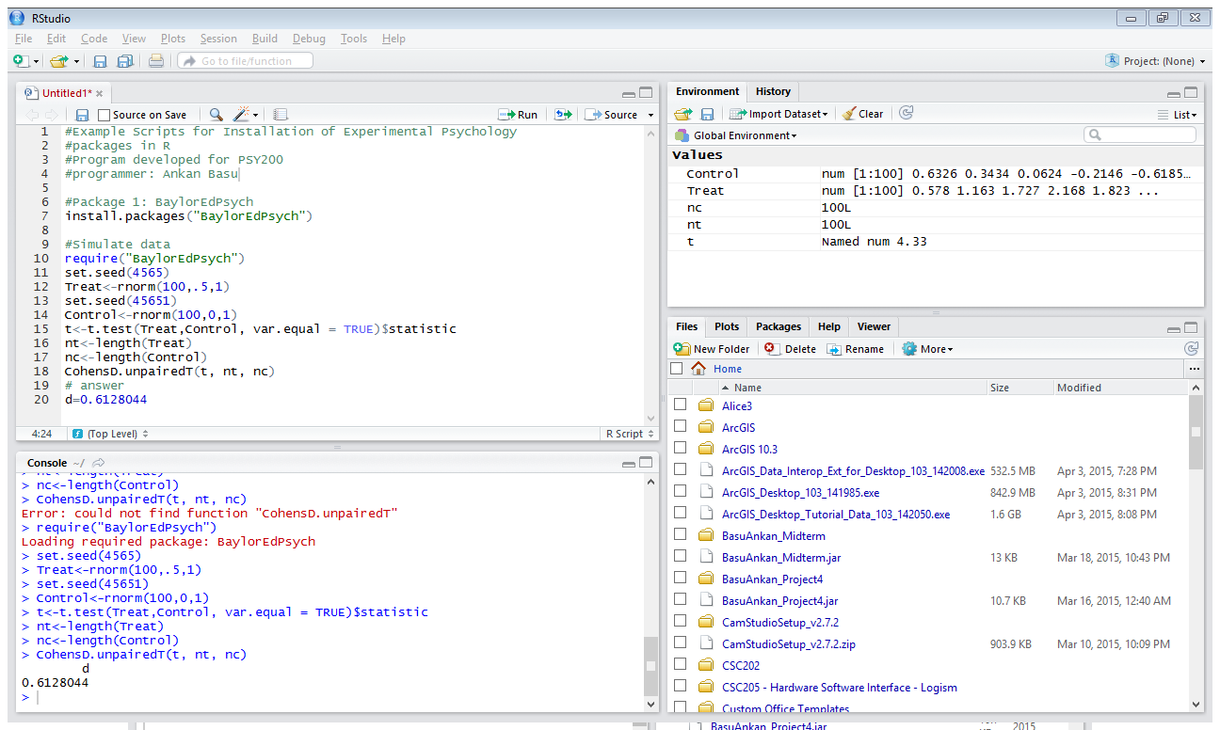

* Modelfree**[4]**: Modelfree is an R package used for model free estimation of psychometric functions developed by Ivan Marin-Franch at the Indiana University. According to the package definition, it provides “local linear estimation of psychometric functions and also provides functions for nonparametric estimation of a psychometric function and for estimation of a derived threshold and slope, and their standard deviations and confidence intervals”. The package was released to experimental psychologists in 2012. This package includes several datasets from various clinical studies around the globe. For example, “01_Moranda” dataset contains a dataset from a study of perimetric sensitivity and response variability in glaucoma with single-stimulus automated perimetry and multiple-stimulus perimetry with verbal feedback. (Miranda, 2008). This package also contains another interesting dataset “02_Levi”. This dataset came from an experimental study of visual detection of path deviation (Levi, 2006).
* MPDiR[5]: MPDiR is a very useful R package that contains several example datasets and examples for modeling psychological data. The package was excellently developed by Kenneth Knoblauch and Laurence T. Maloney which has gained popularity in experimental psychological research community. This package was designed to provide example datasets with functions for various statistical analyses as presented in the exceptionally well accepted book “Modeling Psychophysical Data in R” (Knoblauch K, 2012).

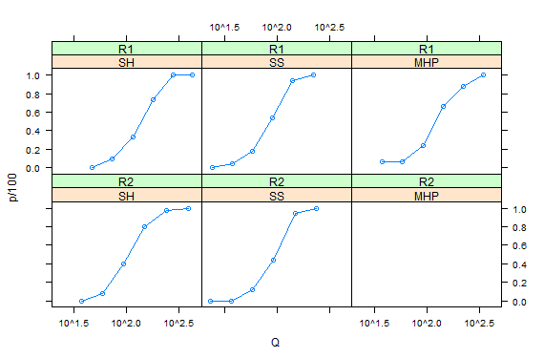

The figure above uses MPDiR functions to show the results from a psychometric study by Hecht S. (1942) where “percent of correct responses as a function of average number of quanta per flash of light at the cornea and the frequency with which it was seen for 5 psychometric functions” were reported.

* NormPsy[6]: According to the software developer, NormPsy was developed to provide “functions for normalizing psychometric test scores. The normalization aims at correcting the metrological properties of the psychometric tests such as the ceiling and floor effects and the curvilinearity (unequal interval scaling). Functions to compute and plot predictions in the natural scale of the psychometric test from the estimates of a linear mixed model estimated on the normalized scores are also provided”. The most recent version of the package was released in February, 2015 to the psychological community under GPL license. For example, one of the functions included in the package is normMMSE, which presents normalized scores for the “Mini Mental State Examinations (MMSE).

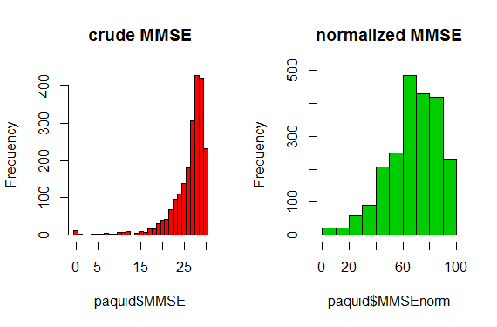

The figure is produced using R from an experimental study of MMSE (Philipps V, 2014) which presents the crude and the normalized scores of the experimental study.

* psy[7]: psy is one of the earlier packages developed in R programming interface by Bruno Falissard in 2012. The package provides basic procedures such as Kappa, ICC, Cronbach alpha, screeplot, and mtmm for evaluation of experimental psychological data. A very interesting dataset included in this package is named “sleep” that came from a study of sleep patterns in mammals (Allison, 1976). 62 different mammals were studied and documented in the paper including humans, cat, horse, cat, cow and many more. A spherical representation of a correlation matrix was developed using the dataset in R as presented below.

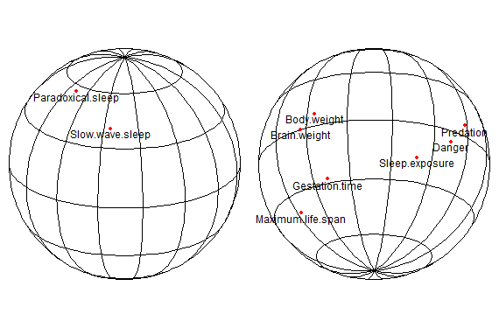

* psych[8]: psych is another latest contribution to the suite of R scripts for experimental psychology released in July of 2015 by William Revelle at the Northwestern University. Psych is one of the most comprehensive packages available for researchers that contains hundreds of useful functions for statistical research using psychological data. Psych is mainly a general purpose toolbox for conducting research in personality, psychometrics and experimental psychology. The manual of the package is over 350 pages and extremely well documented. The package was under development since 2005 and includes the most useful functions for personality, psychometric, and psychological research. The package is also developed to support a textbook in experimental psychology that is available for free at <http://personality-project.org/r/book/>.

For example, detailed descriptive statistics can be easily produced using the package**.** The example below presents interesting results from a psychological study that used the package[9].

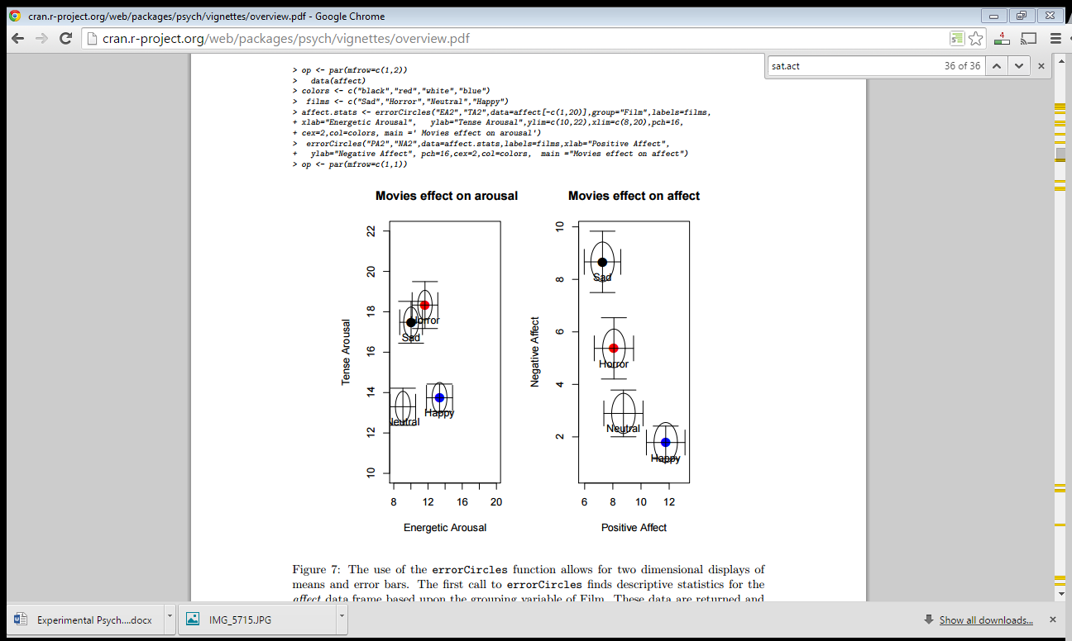

* Other packages: There are several other packages that are available to researchers conducting experimental psychological research such as “psytabs”, “psypsy”, “psychotools” and many more are coming up regularly. A great place to find the latest developments in technology for psychological research using the R interface is the CRAN repository located at:

<http://cran.r-project.org/web/packages/available_packages_by_name.html>

**Conclusion**

Experimental psychology has a long history since the first experimental lab was established by Wilhelm Wundt in 1874. Especially, with the development of computer technology, thousands of utilities and scripts are now being incorporated in experimental psychology in a regular basis. R-stat has become especially popular in the particular field as R was primarily developed to support statistical programming. Hundreds of datasets are available in various packages with example functions used to analyze data. New studies routinely follow such examples to generate dataset that can be easily analyzed and visualized. As more and more packages are coming up from various researchers routinely, experimental psychology will only become more powerful in future.

# References

Allison, T. C. (1976). Sleep in Mammals: Ecological and Constitutional Correlates. *Science*, 732-734.

Cohen, J. (1988). Statistical power analysis for the behavioral sciences (2nd Ed). Mahwah, NJ.

Hecht S., S. S. (1942). Energy, quanta and vision. *Journal of General Physiology*, 819-840.

Knoblauch K, M. L. (2012). *Modeling Psychophysical Data in R.* Springer.

Levi, D. M. (2006). Is the ability to identify deviations in multiple trajectories compromised mised by amblyopia? *Journal of Vision*, 1367-1379.

Miranda, M. A. (2008). “Perimetric sensitivity and response variability in glaucoma with single-stimulus automated perimetry and multiple-stimulus perimetry with verbal feedback. *Acta Ophthalmologica*, 202-206.

Philipps V, A. H.-F. (2014). Normalized mini-mental state examination for assessing cognitive change in population-based brain aging studies. *Neuroepidemiology*, 15-25.

1. The R Project for Statistical Computing; http://www.r-project.org/
2. http://www.r-project.org/
3. http://cran.r-project.org/web/packages/BaylorEdPsych/BaylorEdPsych.pdf
4. http://cran.r-project.org/web/packages/modelfree/modelfree.pdf
5. http://cran.r-project.org/web/packages/MPDiR/MPDiR.pdf
6. http://cran.r-project.org/web/packages/NormPsy/NormPsy.pdf
7. http://cran.r-project.org/web/packages/psy/psy.pdf
8. http://cran.r-project.org/web/packages/psych/psych.pdf
9. http://cran.r-project.org/web/packages/psych/vignettes/overview.pdf